Report by: 1409046  
Role: Level Design & Artist liaison

Game Version: ‘Latest’   
Date Reported: 18/04/2016

QA Status: Passed

Severity: Minor

Priority: Low

Test Introduction:

In this test I wanted to see if the colliders attached to the model would affect the player movement, to do this I removed all of the obstacles from the track and moved the player to the furthest it could to the left then to its furthest to the right.

Expected outcome:

I expect the model to tilt from side to side fully without getting stuck on the floor.

Actual outcome:

When I played the game the ship was unable to get any further than the picture below, and it would regularly reset the model to an upright position.

Screenshot of the bug:

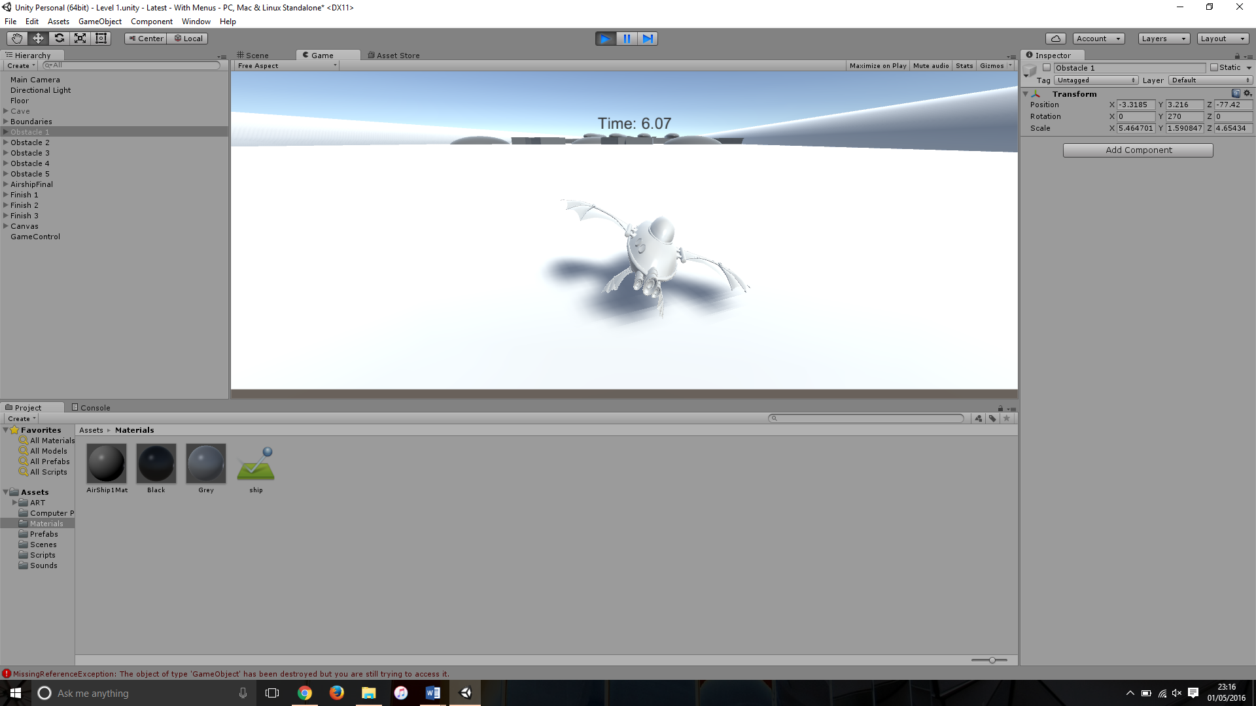

Potential cause:

A potential cause for this could be the box collider that is attached to the bottom of the ship, with the side panes connecting with the floor and stopping any further tilting, the resetting back to upright position could be because of the wing box collider going through the floor and the engine putting it back to its original orientation

Suggested Fix:

To fix this bug I removed the box collider that was used as a base and replaced it with a cylinder collider as this gives a greater rotation range before the wings hit the floor and stop rotation. This seems to have stopped the resetting of the model also.